**Python Data Type: Statements and loops**

Name: Aleksandra Jaworska

Album no. : 162589

Group: WAW_2023_L_N_I_INF7_C4

Student email: [wwx19038@student.warszawa.merito.pl](mailto:wwx19038@student.warszawa.merito.pl)

GitHub link:

https://github.com/AleJawor/Podstawy-Programowania-/blob/main/Python%20Data%20Type%20List.docx

Structure of task presentation:

* The content of the task
* Theoretical issues
* Code
* Code result

1. Write a Python program to construct the following pattern, using a nested loop number.

for i in range(10):

print(str(i) * i)

OUTCOME:

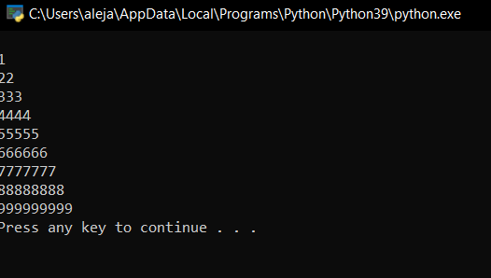

1. Write a Python program to create the multiplication table (from 1 to 10) of a number.

n = int(input("Input a number: "))

for i in range(1, 11):

print(n, 'x', i, '=', n * i)

OUTCOME:

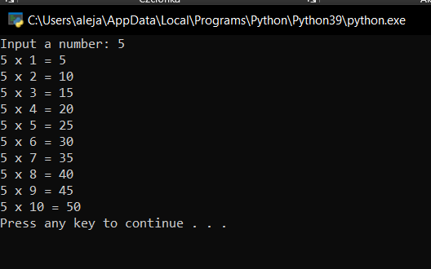

1. Write a Python program to calculate the sum and average of n integer numbers (input from the user). Input 0 to finish.

def average(*args):

return sum(args, 0.0) / len(args)

print(average(*[1, 2, 3, 4]))

print(average(1, 2, 3))

OUTCOME:

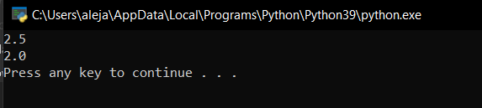

1. Write a Python program to find the median of three values.

a = float(input("Input first number: "))

b = float(input("Input second number: "))

c = float(input("Input third number: "))

if a > b:

if a < c:

median = a

elif b > c:

median = b

else:

median = c

else:

if a > c:

median = a

elif b < c:

median = b

else:

median = c

print("The median is", median)

OUTCOME:

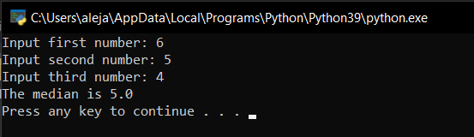

1. Write a Python program to display the sign of the Chinese Zodiac for the given year in which you were born.

year = int(input("Input your birth year: "))

if (year - 2000) % 12 == 0:

sign = 'Dragon'

elif (year - 2000) % 12 == 1:

sign = 'Snake'

elif (year - 2000) % 12 == 2:

sign = 'Horse'

elif (year - 2000) % 12 == 3:

sign = 'Sheep'

elif (year - 2000) % 12 == 4:

sign = 'Monkey'

elif (year - 2000) % 12 == 5:

sign = 'Rooster'

elif (year - 2000) % 12 == 6:

sign = 'Dog'

elif (year - 2000) % 12 == 7:

sign = 'Pig'

elif (year - 2000) % 12 == 8:

sign = 'Rat'

elif (year - 2000) % 12 == 9:

sign = 'Ox'

elif (year - 2000) % 12 == 10:

sign = 'Tiger'

else:

sign = 'Hare'

print("Your Zodiac sign :", sign)

OUTCOME:

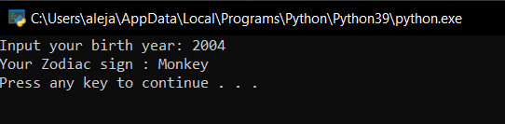

1. Write a Python program to display the astrological sign for a given date of birth.

day = int(input("Input birthday: "))

month = input("Input month of birth (e.g. march, july etc): ")

if month == 'december':

astro_sign = 'Sagittarius' if (day < 22) else 'Capricorn'

elif month == 'january':

astro_sign = 'Capricorn' if (day < 20) else 'Aquarius'

elif month == 'february':

astro_sign = 'Aquarius' if (day < 19) else 'Pisces'

elif month == 'march':

astro_sign = 'Pisces' if (day < 21) else 'Aries'

elif month == 'april':

astro_sign = 'Aries' if (day < 20) else 'Taurus'

elif month == 'may':

astro_sign = 'Taurus' if (day < 21) else 'Gemini'

elif month == 'june':

astro_sign = 'Gemini' if (day < 21) else 'Cancer'

elif month == 'july':

astro_sign = 'Cancer' if (day < 23) else 'Leo'

elif month == 'august':

astro_sign = 'Leo' if (day < 23) else 'Virgo'

elif month == 'september':

astro_sign = 'Virgo' if (day < 23) else 'Libra'

elif month == 'october':

astro_sign = 'Libra' if (day < 23) else 'Scorpio'

elif month == 'november':

astro_sign = 'Scorpio' if (day < 22) else 'Sagittarius'

print("Your Astrological sign is :", astro_sign)

OUTCOME:

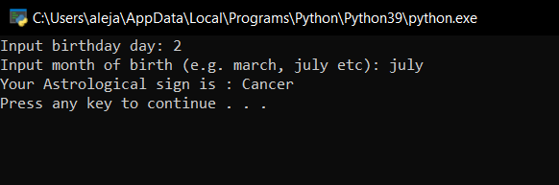

1. Write a Python program that reads two integers representing a month and day and prints the season for that month and day.

month = input("Input the month (e.g. January, February etc.): ")

day = int(input("Input the day: "))

if month in ('January', 'February', 'March'):

season = 'winter'

elif month in ('April', 'May', 'June'):

season = 'spring'

elif month in ('July', 'August', 'September'):

season = 'summer'

else:

season = 'autumn'

if (month == 'March') and (day > 19):

season = 'spring'

elif (month == 'June') and (day > 20):

season = 'summer'

elif (month == 'September') and (day > 21):

season = 'autumn'

elif (month == 'December') and (day > 20):

season = 'winter'

print("Season is", season)

OUTCOME:

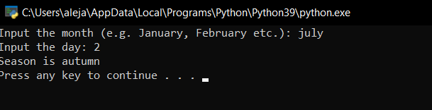

1. Write a Python program to find those numbers which are divisible by 7 and multiples of 5, between 1500 and 2700 (both included).

nl = []

for x in range(1500, 2701):

if (x % 7 == 0) and (x % 5 == 0):

nl.append(str(x))

print(','.join(nl))

OUTCOME:

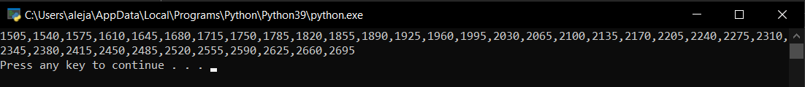

1. Write a Python program to guess a number between 1 and 9.

import random

target_num, guess_num = random.randint(1, 10), 0

while target_num != guess_num:

guess_num = int(input('Guess a number between 1 and 10 until you get it right : '))

print('Well guessed!')

OUTCOME:

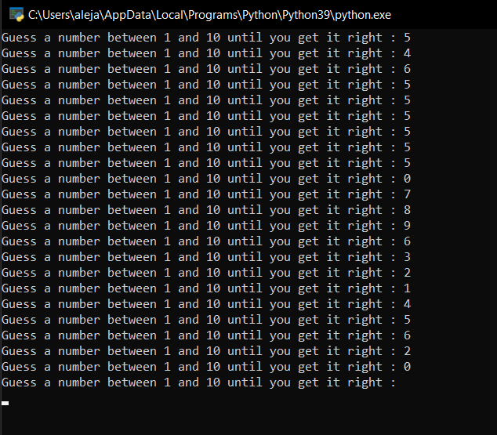

1. Write a Python program that accepts a word from the user and reverses it.

word = input("Input a word to reverse: ")

for char in range(len(word) - 1, -1, -1):

print(word[char], end="")

print("\n")

OUTCOME:

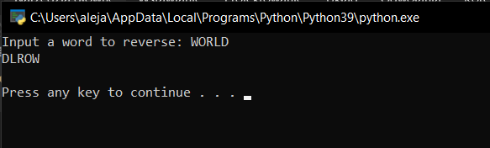

1. Write a Python program to count the number of even and odd numbers in a series of numbers.

numbers = (1, 2, 3, 4, 5, 6, 7, 8, 9)

count_odd = 0

count_even = 0

for x in numbers:

if not x % 2: # If 'x' modulo 2 equals 0, it's even

count_even += 1

else:

count_odd += 1

print("Number of even numbers:", count_even)

print("Number of odd numbers:", count_odd)

OUTCOME:

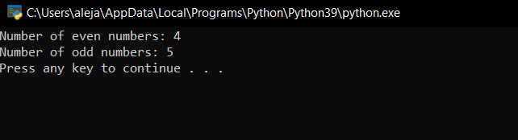

1. Write a Python program that iterates the integers from 1 to 50. For multiples of three print "Fizz" instead of the number and for multiples of five print "Buzz". For numbers that are multiples of three and five, print "FizzBuzz".

for fizzbuzz in range(51):

if fizzbuzz % 3 == 0 and fizzbuzz % 5 == 0:

print("fizzbuzz")

continue

elif fizzbuzz % 3 == 0:

print("fizz")

continue

elif fizzbuzz % 5 == 0:

print("buzz")

continue

print(fizzbuzz)

OUTCOME:

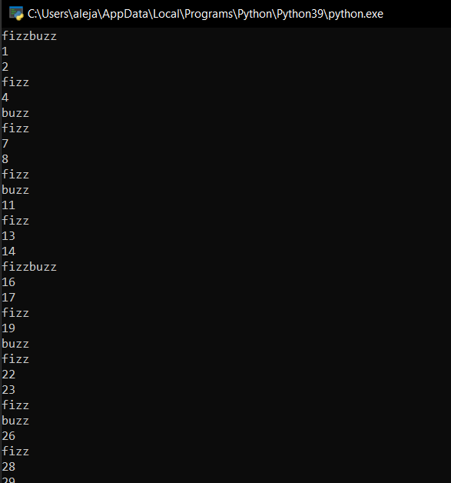

1. Write a Python program that takes two digits m (row) and n (column) as input and generates a two-dimensional array. The element value in the i-th row and j-th column of the array should be i*j.

row_num = int(input("Input number of rows: "))

col_num = int(input("Input number of columns: "))

multi_list = [[0 for col in range(col_num)] for row in range(row_num)]

for row in range(row_num):

for col in range(col_num):

multi_list[row][col] = row * col

print(multi_list)

OUTCOME:

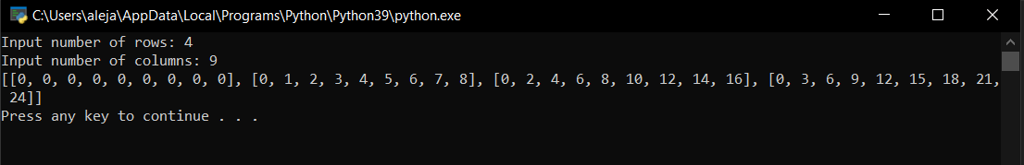

1. Write a Python program that accepts a sequence of lines (blank line to terminate) as input and prints the lines as output (all characters in lower case).

lines = []

while True:

l = input()

if l:

lines.append(l.upper())

else:

break;

for l in lines:

print(l)

OUTCOME:

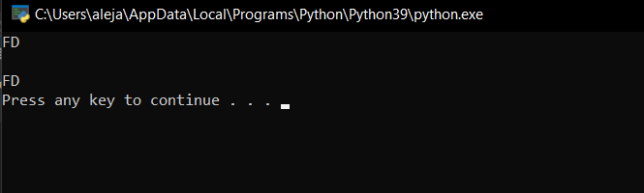

1. Write a Python program that accepts a string and calculates the number of digits and letters.

s = input("Input a string")

d = l = 0

for c in s:

if c.isdigit():

d = d + 1

elif c.isalpha():

l = l + 1

else:

pass

print("Letters", l)

print("Digits", d)

OUTCOME:

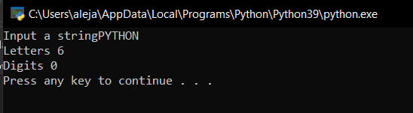

1. Write a Python program to print the alphabet pattern 'A'.

result_str = ""

for row in range(0, 7):

for column in range(0, 7):

if (((column == 1 or column == 5) and row != 0) or ((row == 0 or row == 3) and (column > 1 and column < 5))):

result_str = result_str + "*" # Append '*' to the 'result_str'

else:

result_str = result_str + " " # Append space (' ') to the 'result_str'

result_str = result_str + "\n" # Add a newline character after each row in 'result_str'

print(result_str)

OUTCOME:

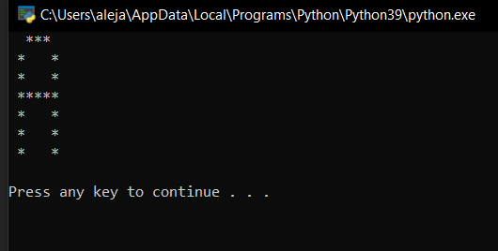

1. Write a Python program to print the alphabet pattern 'D'.

result_str = ""

for row in range(0, 7):

for column in range(0, 7):

if (column == 1 or ((row == 0 or row == 6) and (column > 1 and column < 5)) or (column == 5 and row != 0 and row != 6)):

result_str = result_str + "*" # Append '*' to the 'result_str'

else:

result_str = result_str + " " # Append space (' ') to the 'result_str'

result_str = result_str + "\n" # Add a newline character after each row in 'result_str'

print(result_str)

OUTCOME:

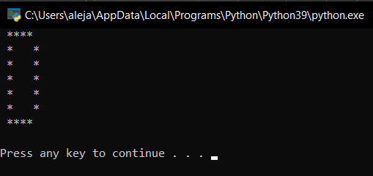

1. Write a Python program to print the alphabet pattern 'E'.

result_str = ""

for row in range(0, 7):

for column in range(0, 7):

if (column == 1 or ((row == 0 or row == 6) and (column > 1 and column < 6)) or (row == 3 and column > 1 and column < 5)):

result_str = result_str + "*" # Append '*' to the 'result_str'

else:

result_str = result_str + " " # Append space (' ') to the 'result_str'

result_str = result_str + "\n" # Add a newline character after each row in 'result_str'

print(result_str)

OUTCOME:

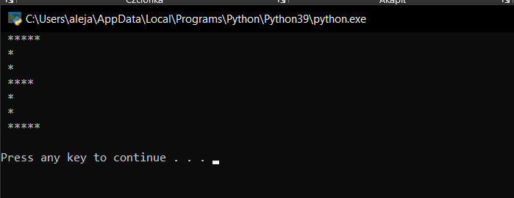

1. Write a Python program to check whether an alphabet is a vowel or consonant.

l = input("Input a letter of the alphabet: ")

if l in ('a', 'e', 'i', 'o', 'u'):

print("%s is a vowel." % l) # Display a message stating that the input letter is a vowel

elif l == 'y':

print("Sometimes the letter y stands for a vowel, sometimes for a consonant.")

else:

print("%s is a consonant." % l)

OUTCOME:

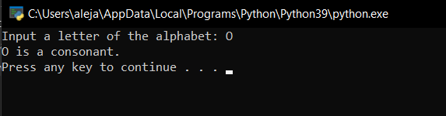

1. Write a Python program to convert a month name to a number of days.

print("List of months: January, February, March, April, May, June, July, August, September, October, November, December")

'month_name'

month_name = input("Input the name of Month: ")

if month_name == "February":

print("No. of days: 28/29 days")

elif month_name in ("April", "June", "September", "November"):

print("No. of days: 30 days")

elif month_name in ("January", "March", "May", "July", "August", "October", "December"):

print("No. of days: 31 days")

else:

print("Wrong month name")

OUTCOME:

